ECE 3331

SIGNAL PROCESSING

LAB 01

Ziqin Shang

250890594

1. (5 points) Generate and plot a continuous-time like1 sinusoidal signal with a magnitude of 1 and frequency of 4 Hz in the time interval of [0, 1] sec (use an increment of 0.001 sec representing a sampling rate of 1000 Hz which is very high compared to 4 Hz).

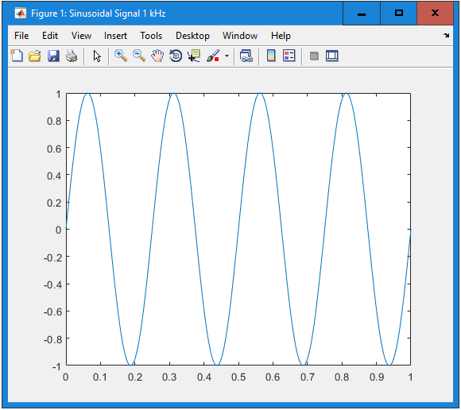

Figure1. Sinusoidal Signal 1 kHz

2. (25 points) Generate and plot a discrete sinusoidal signal with the same frequency and time interval as before, with various sampling frequencies of 100 Hz, 25 Hz, 12 Hz, 8 Hz and 5 Hz. To show these signals you can use the MATLAB commands stem and hold on.

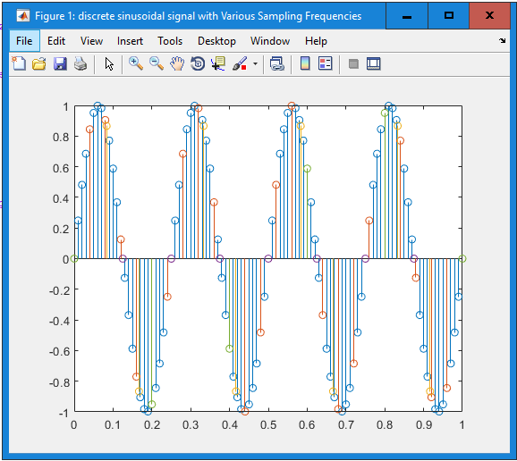

Figure2. Sinusoidal Signal with various sampling frequencies

3. (10 points) Is it always possible to reconstruct the original signal after it is sampled?

No, because the values are only taken at finite discrete values after sampling the signals, due to discretization, there will be some amount of information loss, however it can be reduced by higher sampling frequency.

4. (10 points) A sinusoidal signal is determined by its frequency, amplitude and phase. Can you retrieve all this information from the sampled signal?

These information can be retrieved as long as the frequency of sampling does not reach the level that signal will become aliased, which is 2\*Fmax. However, due to the natural discretization error of sampling, the exact signal is not possible to replicate completely, since the information is not 100% precise.

5. Optional (+5 points): Let us assume fsampling = 2 × fsignal. Is it important at what point (or time) the sampling should be started? If yes, describe why and plot the different results.

Yes, the starting point is very important because when the signal is offset, the points that are being sampled change too, resulting in sampled signals that are very different from each other.

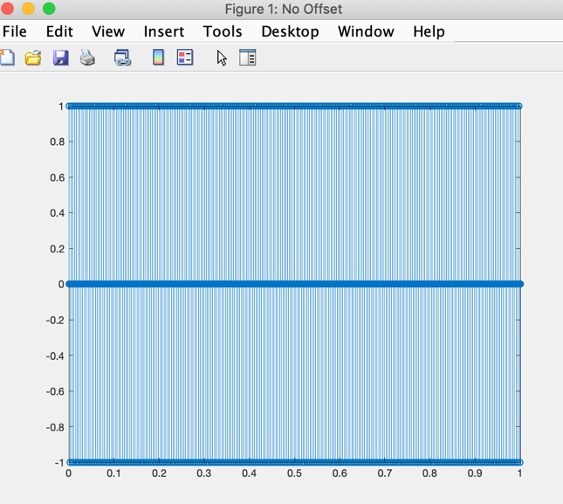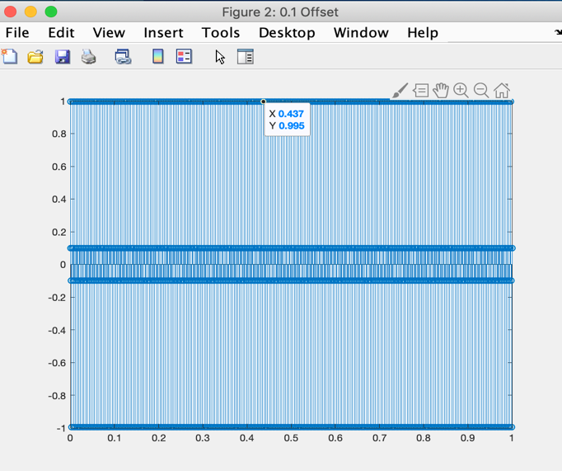

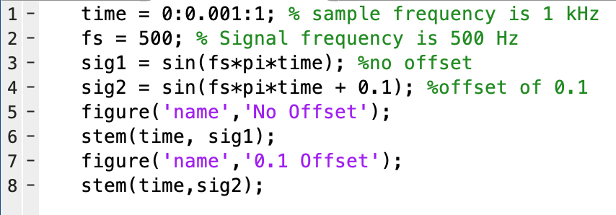

1. For each of these three methods, do the following:

• (5 points) Draw a system block diagram.

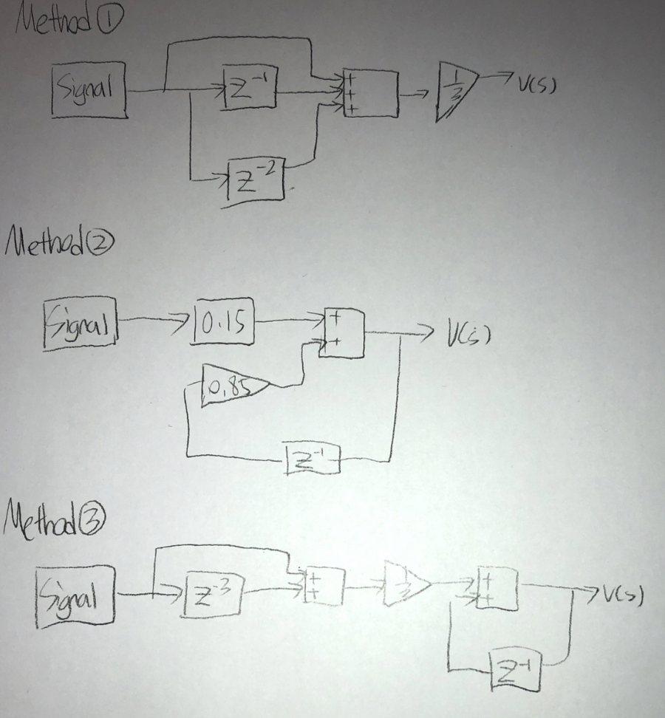

• (10 Points) Calculate the impulse response (i.e., response of the system with zero initial condition to the unit sample signal). This can be done manually or by writing an appropriate MATLAB code. Note that the algorithm used in Method 1 is a finite impulse response (FIR) filter, which means its impulse response function has a finite number of nonzero elements. On the other hand, the algorithms used in Methods 2 and 3 are recursive, therefore their impulse responses may be infinitely long. In the latter case, it is sufficient to calculate 5-10 samples of the impulse response functions.

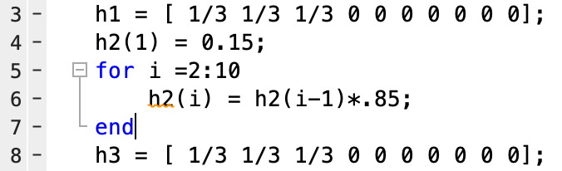

• (5 points) Compare the algorithms used in Methods 1 and 3 based on their difference equations and their impulse response functions.

Based on figure 4 and 6 shown below, the result is very similar, with magnification of figure 6, it can be seen that method 3 provides better filtering and decreased fluctuation.

2. (15 points) Write an m-file to load the input data and implement the difference equation.

Please see attached file: ECE3331LAB01P3.m

3. (5 points) Plot the results for these three methods along with the original input data and compare them to find out which method results in less fluctuations?

Please see Figure7.Different methods, method 2 provides least fluctuation.

4. (10 points) Calculate the results for the three methods using the impulse responses and the conv function. Compare the results to the corresponding results calculated in the previous part. Describe if there is any difference.

Please see figure 8-11, the convolutions between the input signal and unit impulse function is very similar in method 1 and 3, however in method 2 there is significant change, this is due to the limited sample size of method 2, if there is infinite sample size the result will be the same with the input signal.

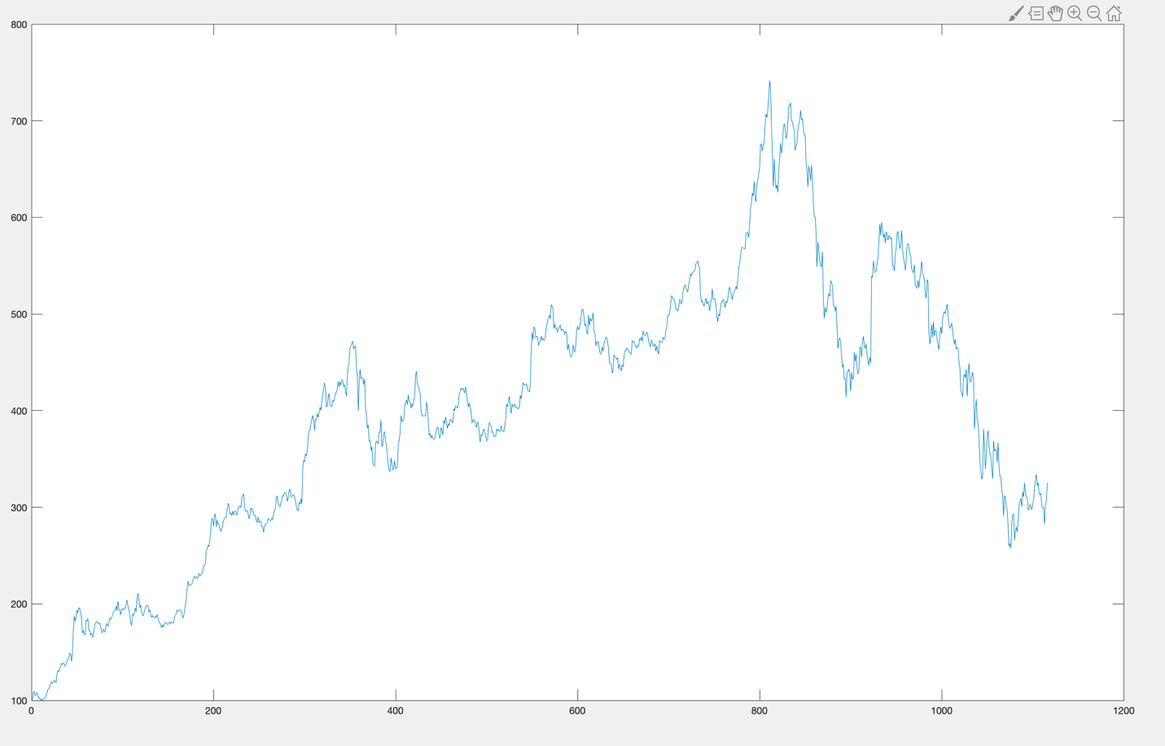

Figure3.GOOG

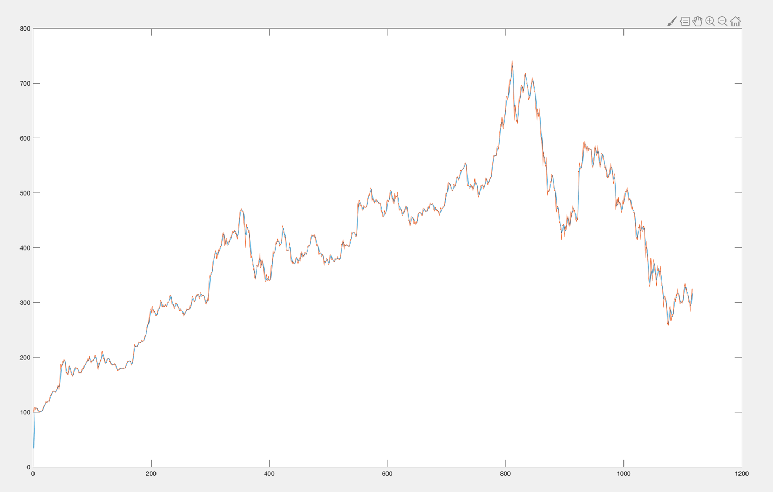

Figure4.V average 1

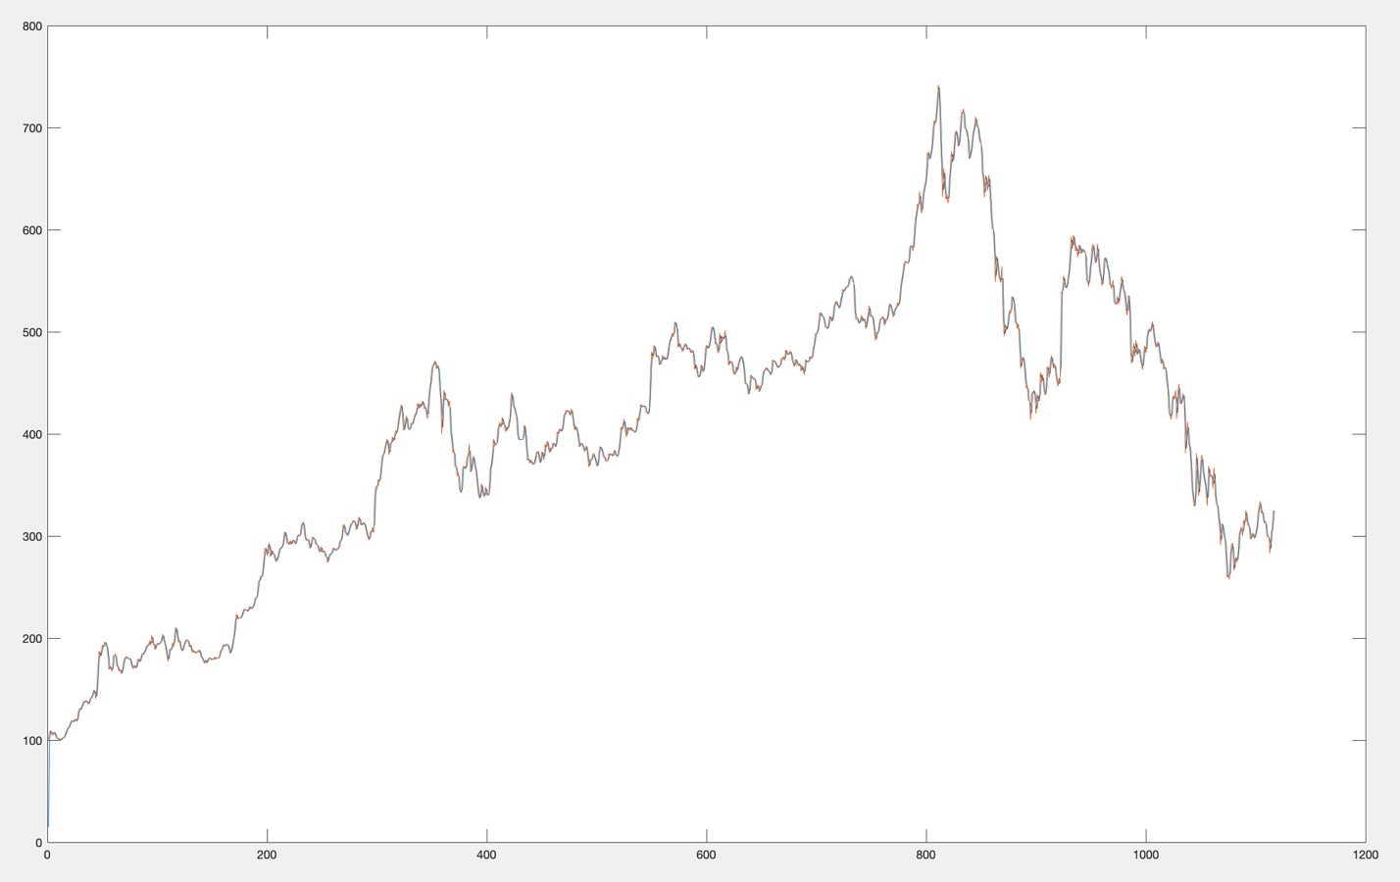

Figure5.V average 2

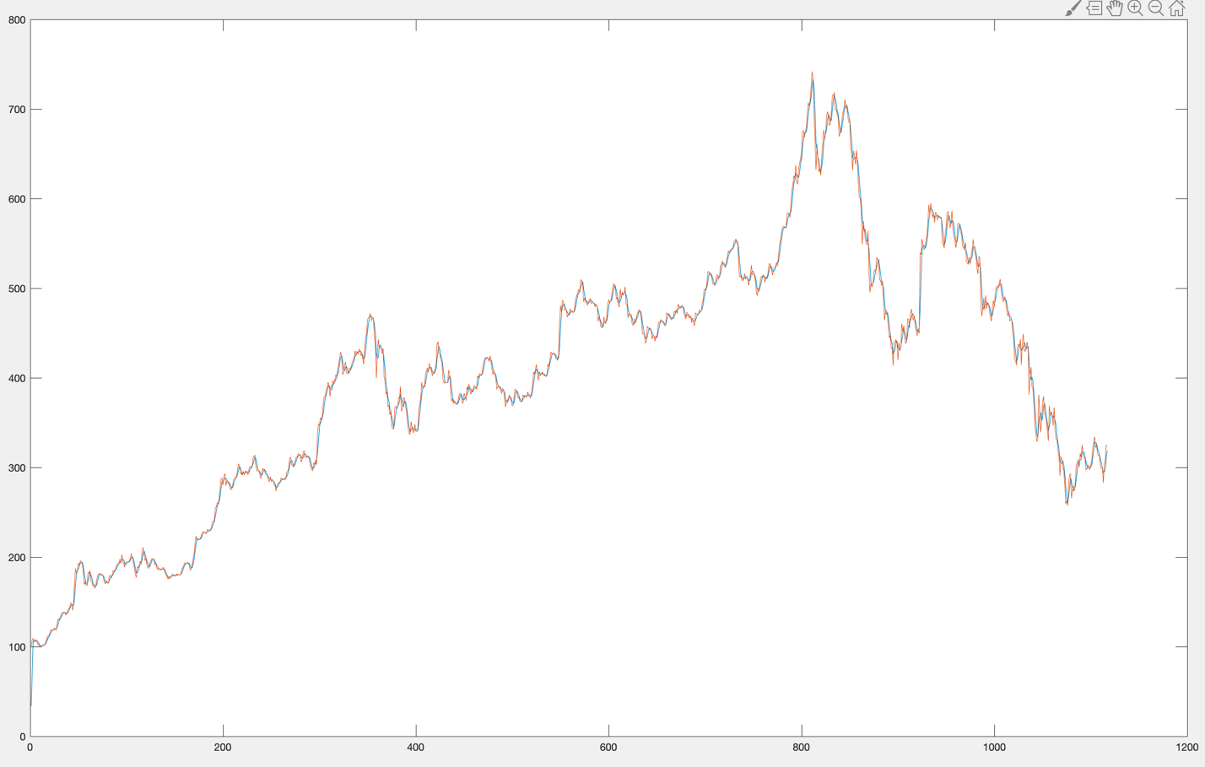

Figure6.V average 3

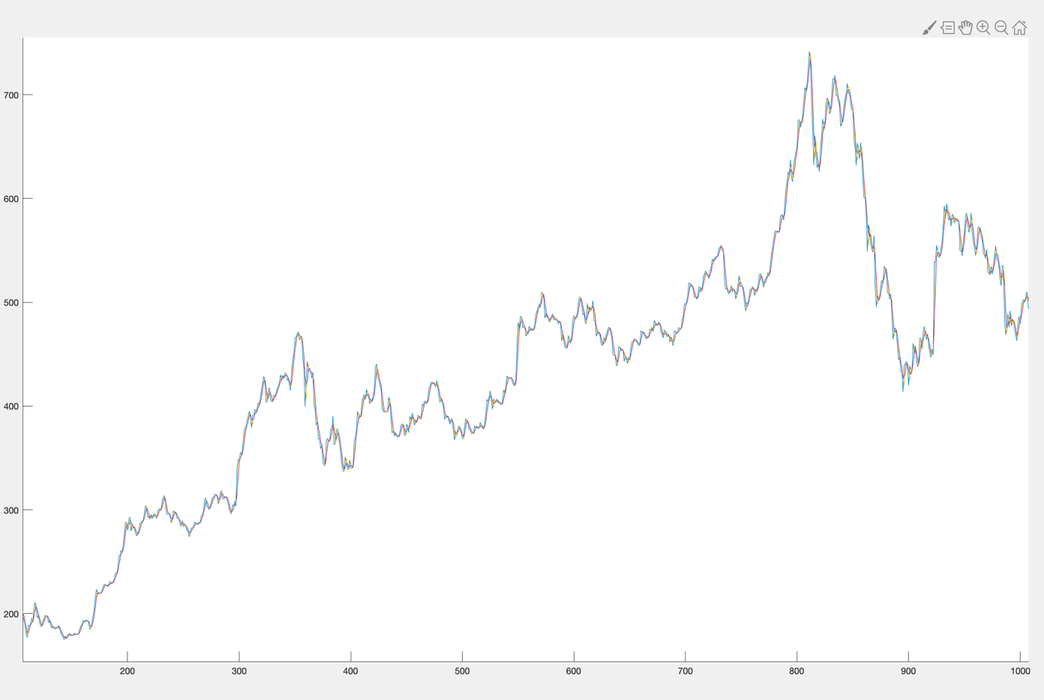Figure7.Different methods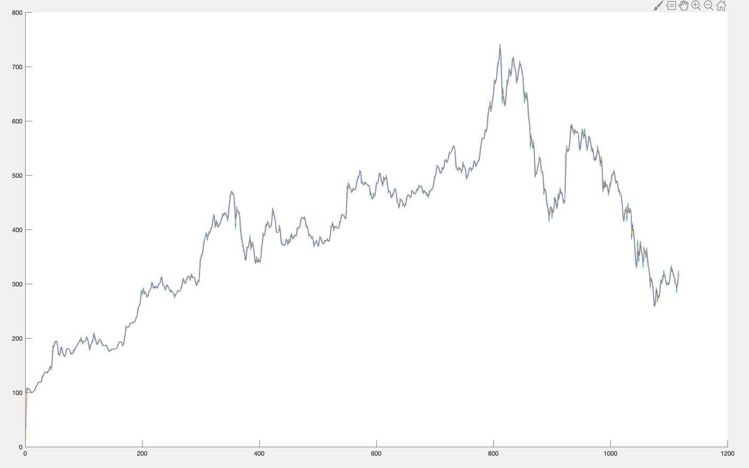Figure8.Average values

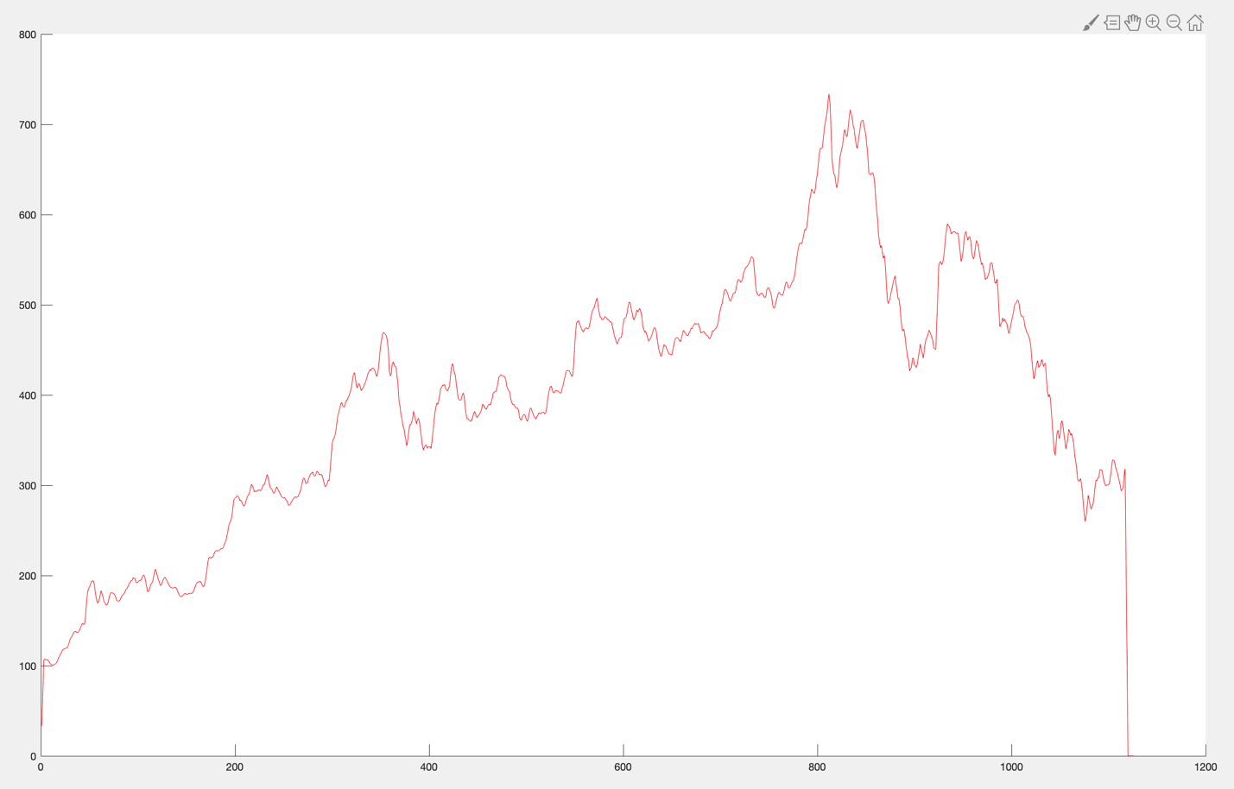

Figure9. Convolution vs Average method 1

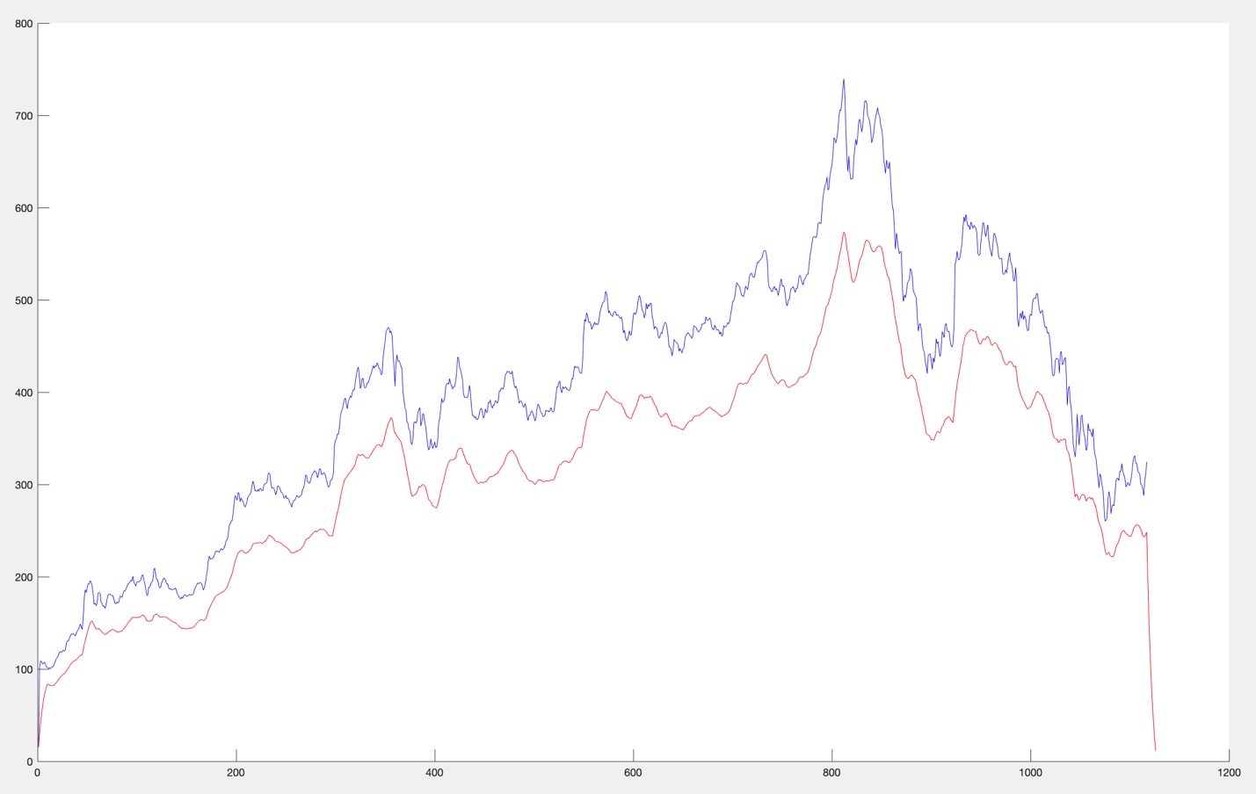

Figure10. Convolution vs Average method 2

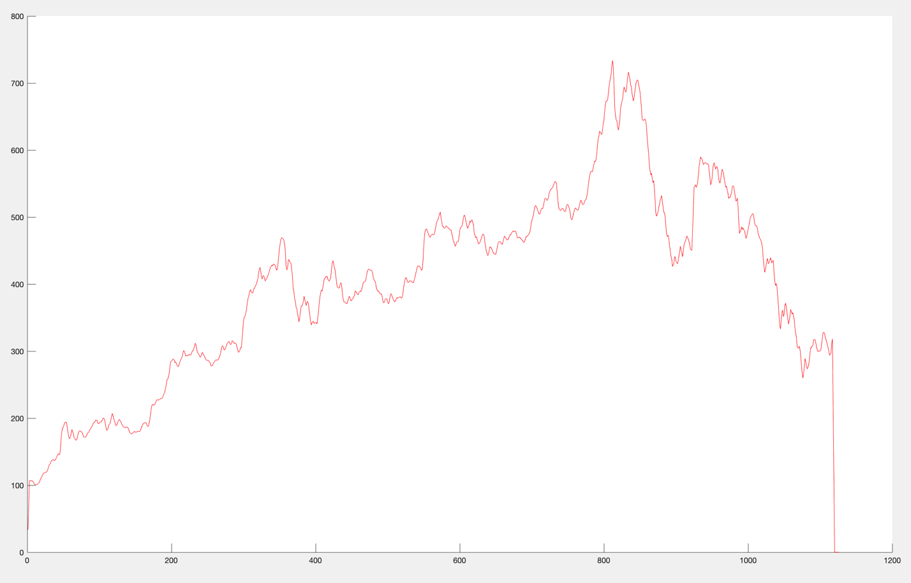

Figure11. Convolution vs Average method 3